This was back from February 2019… I lost my old reports (like I’m going to look for it) so I have to make a new one. I wanted to combine these too just for the comparision.

Also, as far as I’m aware, Cathay Pacific will use an Airbus A350-1000 on this route for a while. When it returns to the Boeing 777-300ER, it will be in a different configuration (as in 3x4x3 instead of 3x3x3).

# Outbound – CX807

Usually I have a decent enough experience departing Chicago. Not really for the International Terminal. TSA Precheck doesn’t even exist here, and everyone screams a lot. The good part is that there’s food… from things I haven’t even heard about (no McDonalds airside, as far as I’m aware). And UNAVOIDABLE Duty Free!

No, do not follow the sign for the exit. It means that you have to re-clear security… and with it having no TSA Precheck… not an option.

The good part about this terminal is that it’s small, so not extreme walking required.

Some views around the terminal… I spy with my little eyes THE QUEEN!

And the plane has arrived. I believe the catering is done by Do & Co based on the truck.

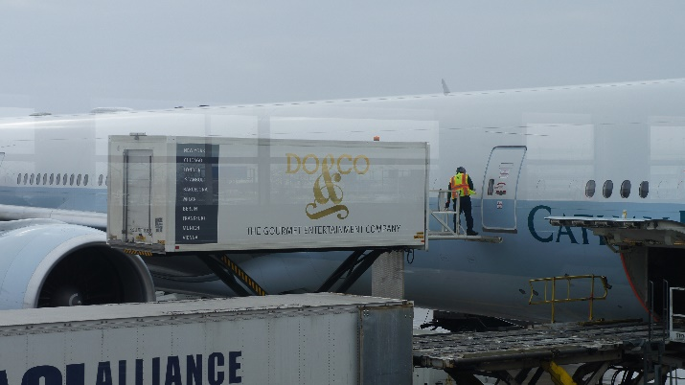

Business Class and Premium Economy looks ok.

The 3x3x3 configuration is appreciated and will be missed. Note that I included pictures from the return flight here (I was in the other side)

Seat pitch is 32” which is decent. I also appreciated the storage pockets.

IFE screen is a standard 9” and contains a nose camera.

Given our 20 – minute delay, we had a quick taxi to the runway and were in the skies soon. To be fair, the runway we used is closer to Terminal 5.

Seatback contents were in a bag (I ripped it apart to get the above picture, I don’t know if they reuse them or toss them, but I lean more to the reuse side).

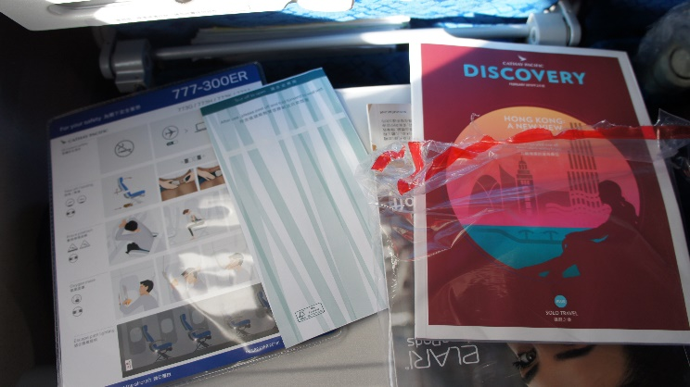

I ordered a Diet Coke, though they only had Coke Zero. Peanuts were served with it.

I do appreciate that they distribute menus. English and Cantonese is available.

The meal service is very different. First, after departure, they serve you a meal, then they serve another meal in the middle of the flight, and finally, they just lock down for landing. I would probably order a ramen noodles at the end of the flight just so I have power when landing… though they ran out.

Anyways the main meal is served about an hour after departure. I choose the mashed potato option (tray is upper left image, with full can of Perrier). My seatmate choose the chicken and rice. (Upper right image).

There is a chocolate served with it (middle left image). I had the salad first, then opened the entrée. Salad was decent, it was a turkey coleslaw with mostly turkey. Butter was rock hard (middle right image). I found that the entrée was pretty good, and even though I had a full lunch, I finished eating (lower pictures show entrée and portion size relative to iPhone 6S).

Best part of the meal was the ice cream bar (upper pictures). Water was included with the meal, and I asked for tea after trays were picked up.

Midflight meal was also decent. I had the chicken. Multiple things to complain about. Bread was rock hard. I believe I tossed it around and found it comparable to a rock. The shrimp entrée (upper right) and chicken entrée (lower right) were both ok, I ordered the chicken entrée. Fruit was also served, I thought it was ok.

I checked out the entertainment system. Pretty decent… because there was the nose camera.

But entertainment was also good. The movie Johnny English Strikes Again was pretty good.

And Wi-Fi was available. I am not sure who the provider is but believe it is Gogo. It may vary based on aircraft, though the login page leads me to believe it’s Gogo. Not sure what to think of the disputed flight arrival time.

